Assignment 1

Raahul M

**Task** - To implement OWASP top 10 Vulnerabilities

**Platform used** - TryHackMe Room; Name: OWASP Top 10–2021

1. Broken access control

Task Performed:

**Insecure Direct Object Reference** - accessing resources you wouldn't ordinarily be able to see. This occurs when the programmer exposes a Direct Object Reference.

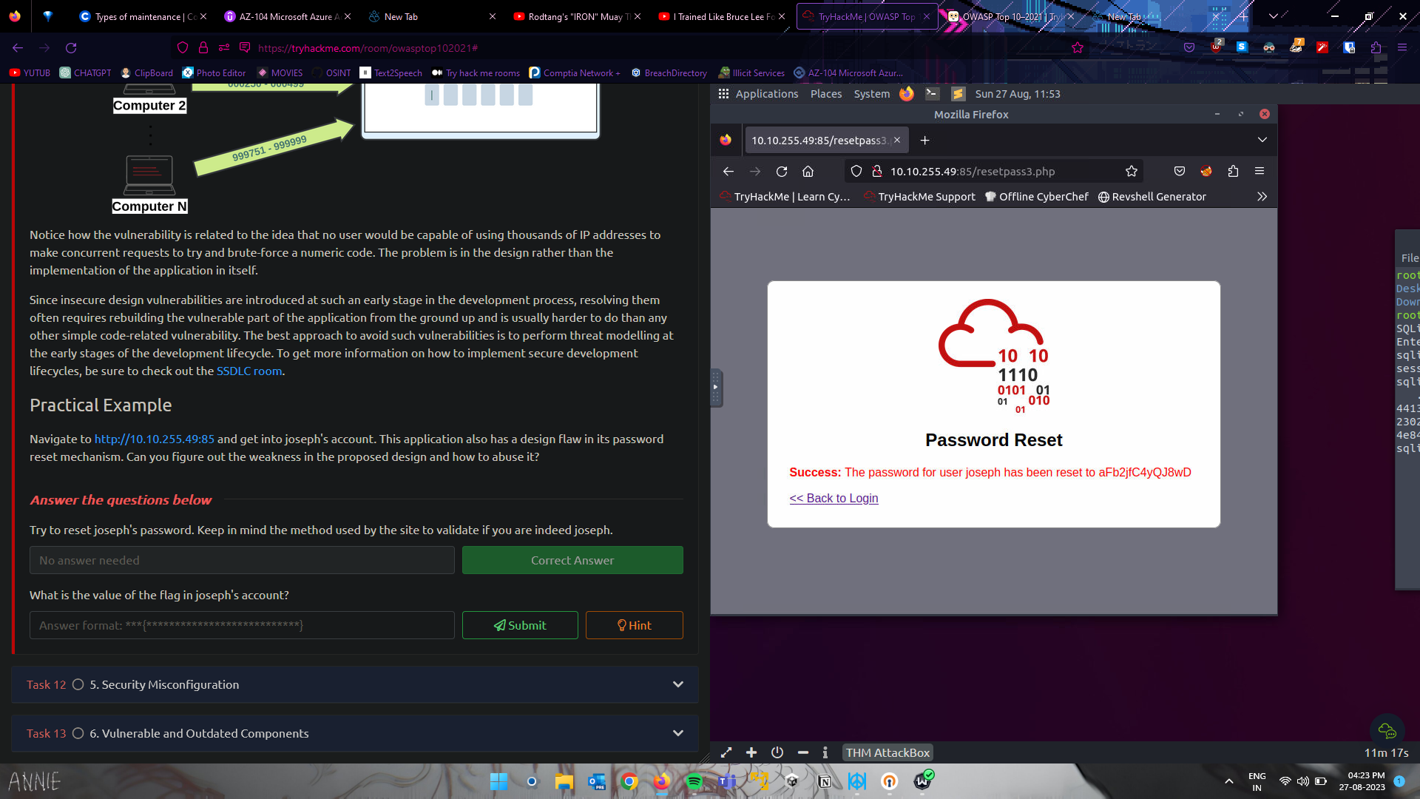

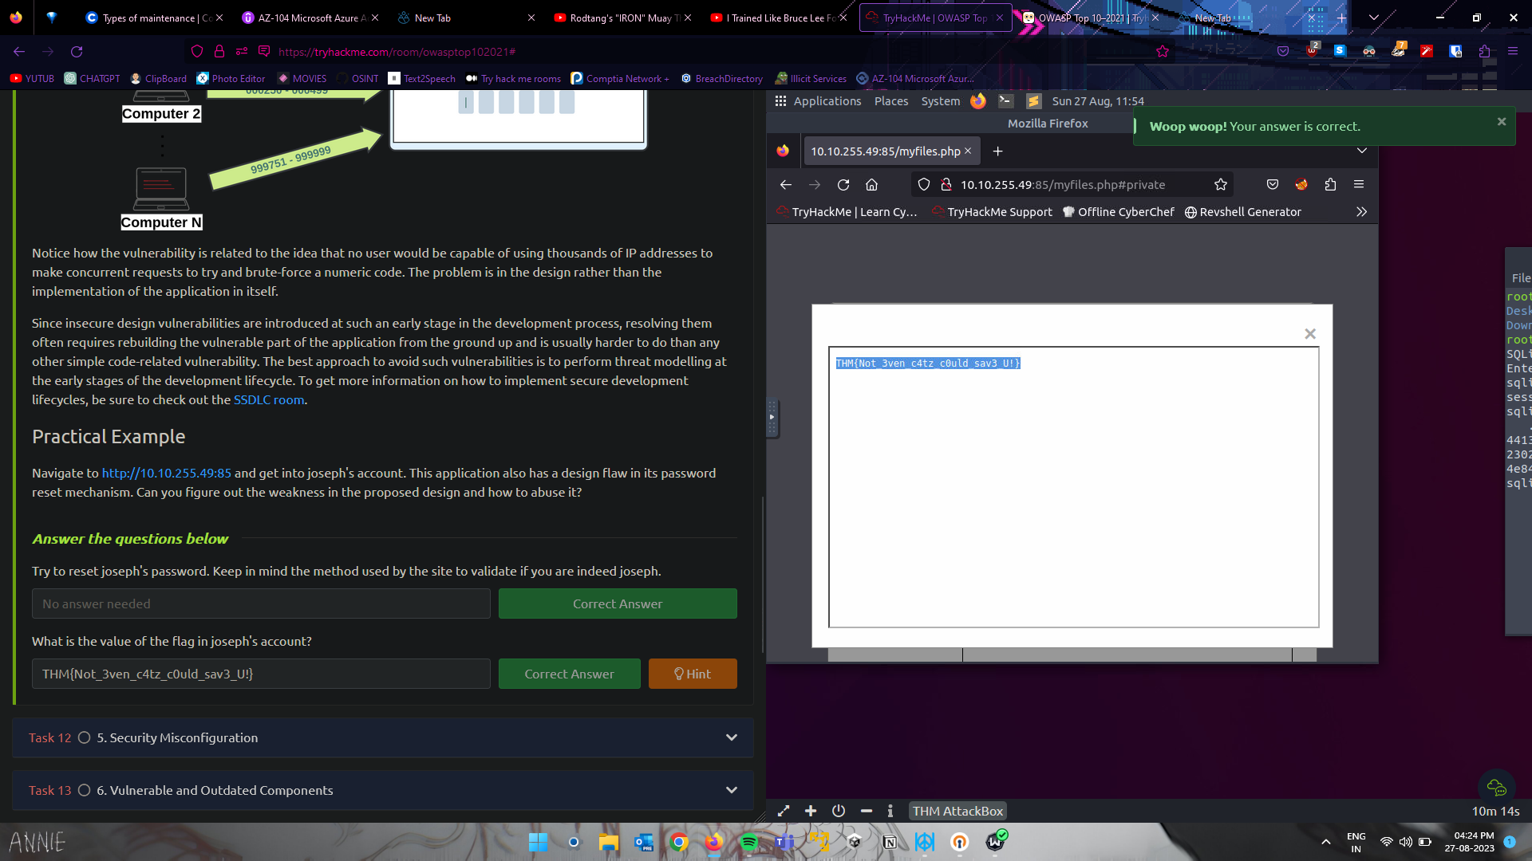

Logged in using the given credentials, changed the ID no. and gained access to the flag

1. Cryptographic failure

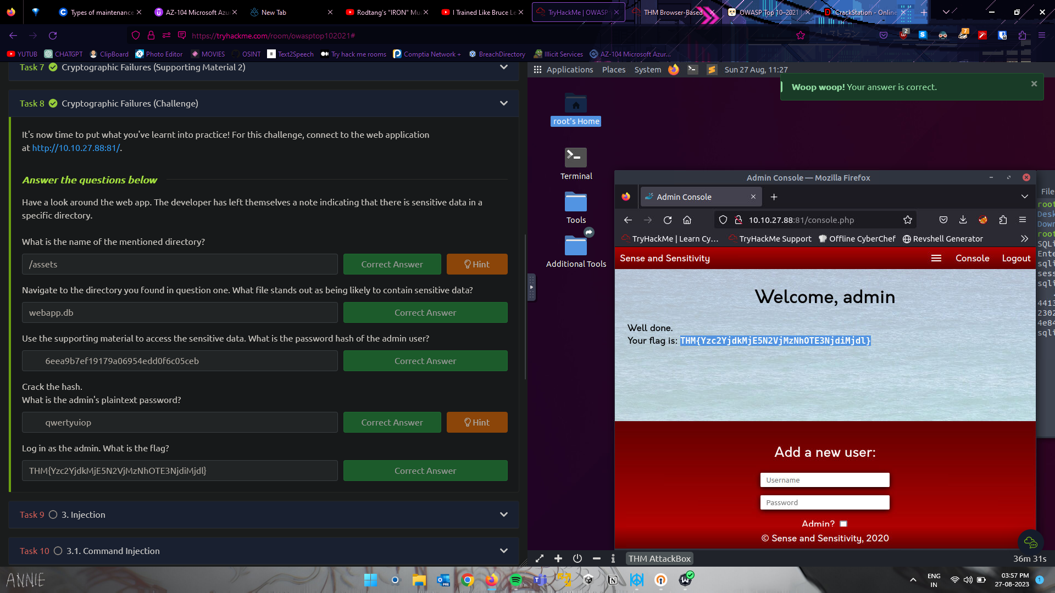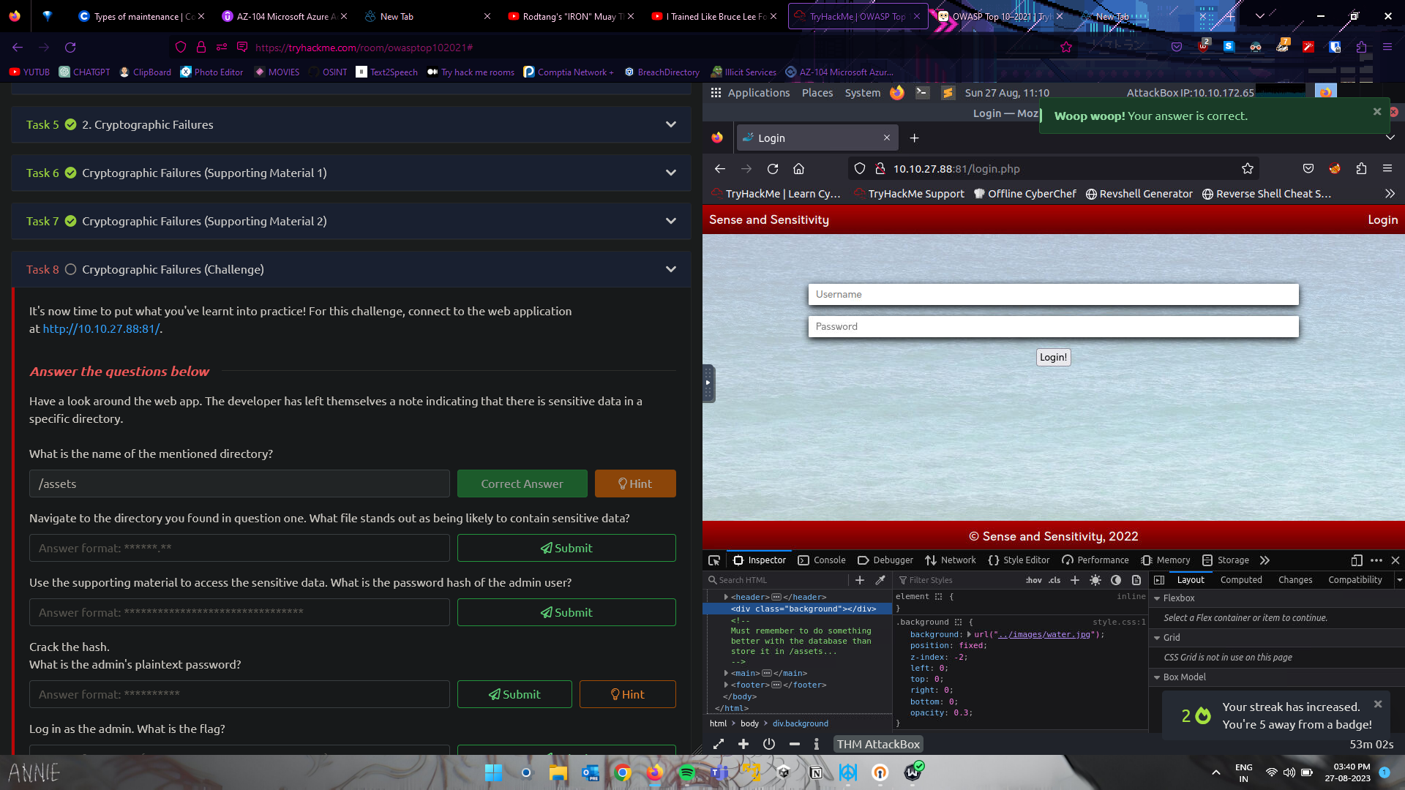

Found some lead in the source code , downloaded the SQLite db file , got the password hash and gained access to admin

1. Injection

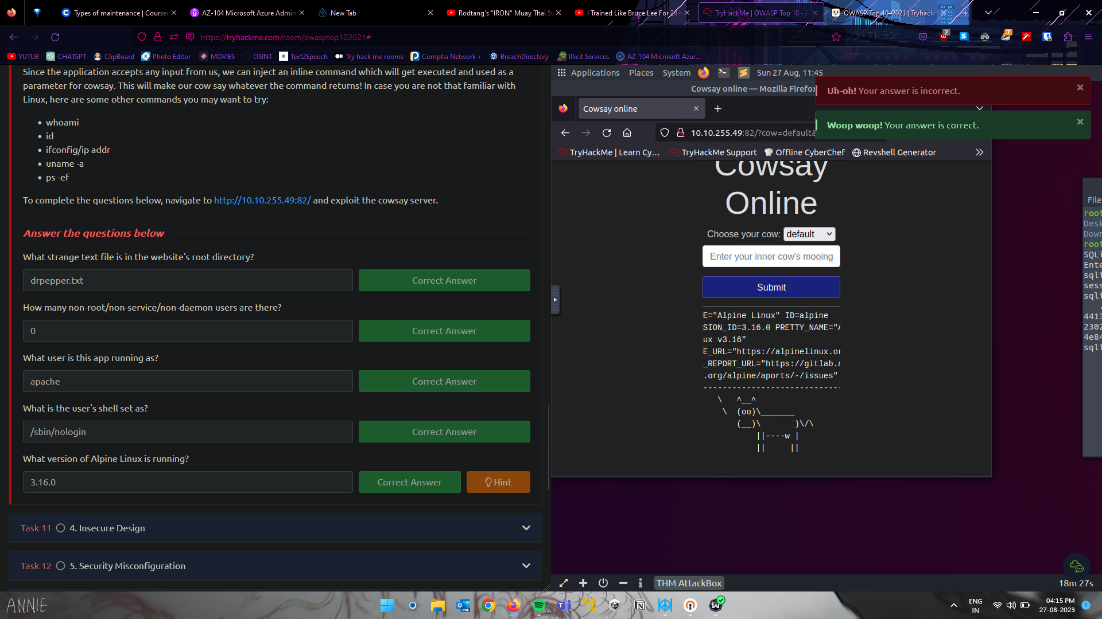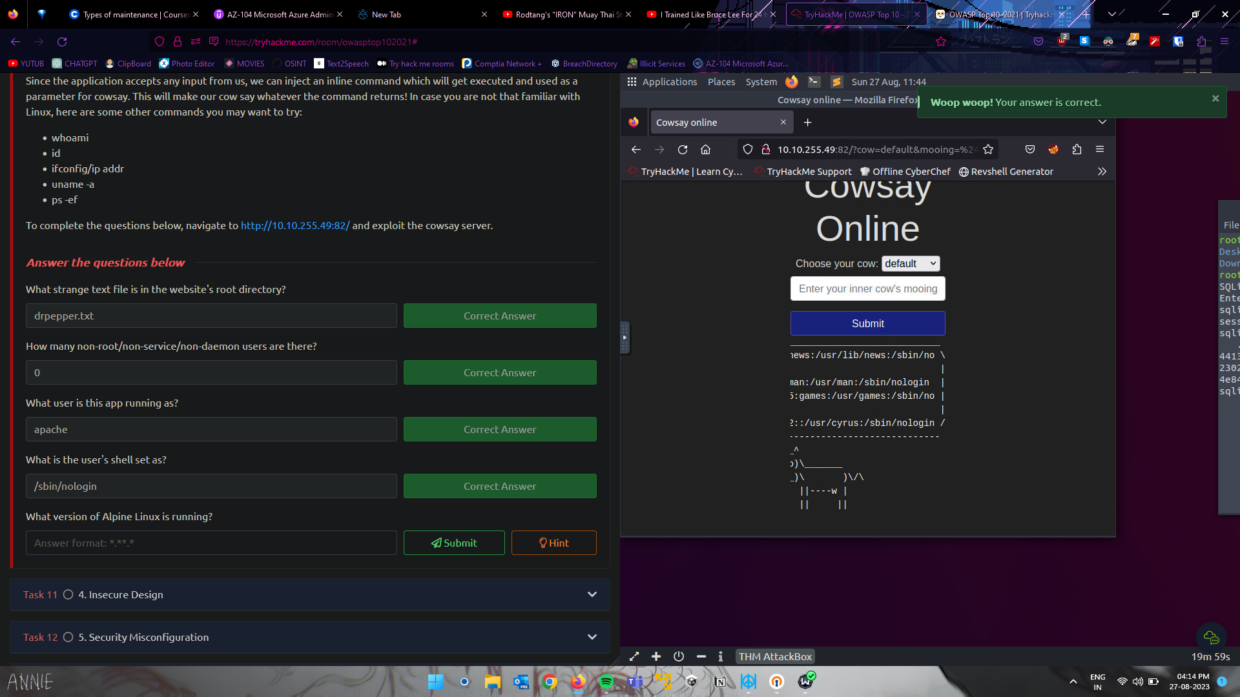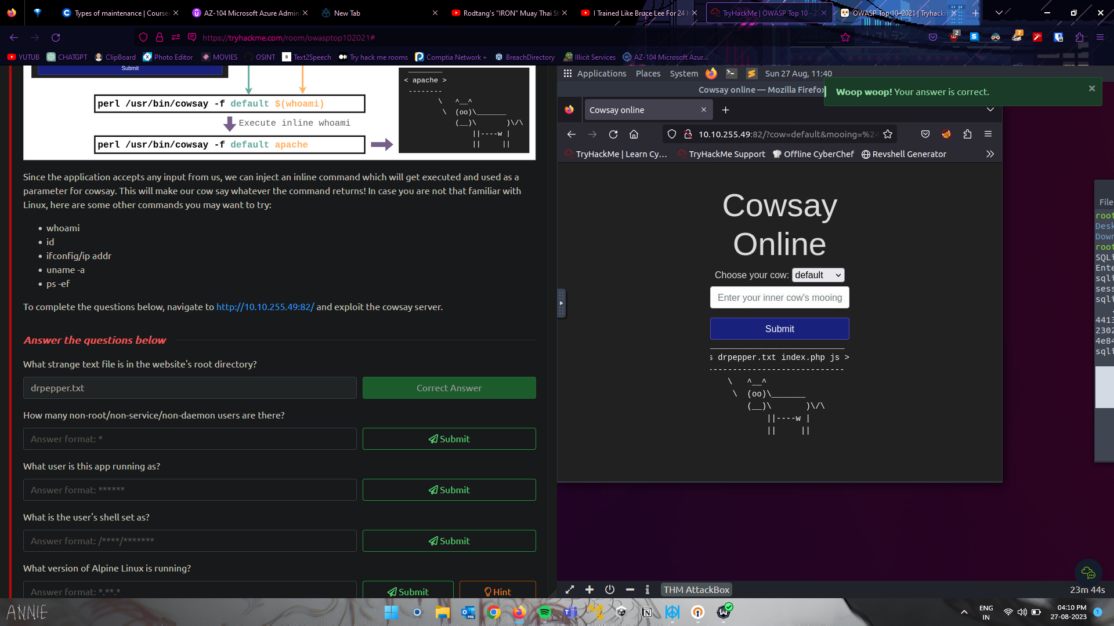

Made use of Bash scripting to gather information

1. Insecure Design



Made use of weak Password reset security question to gain access to the account

1. Security Misconfiguration

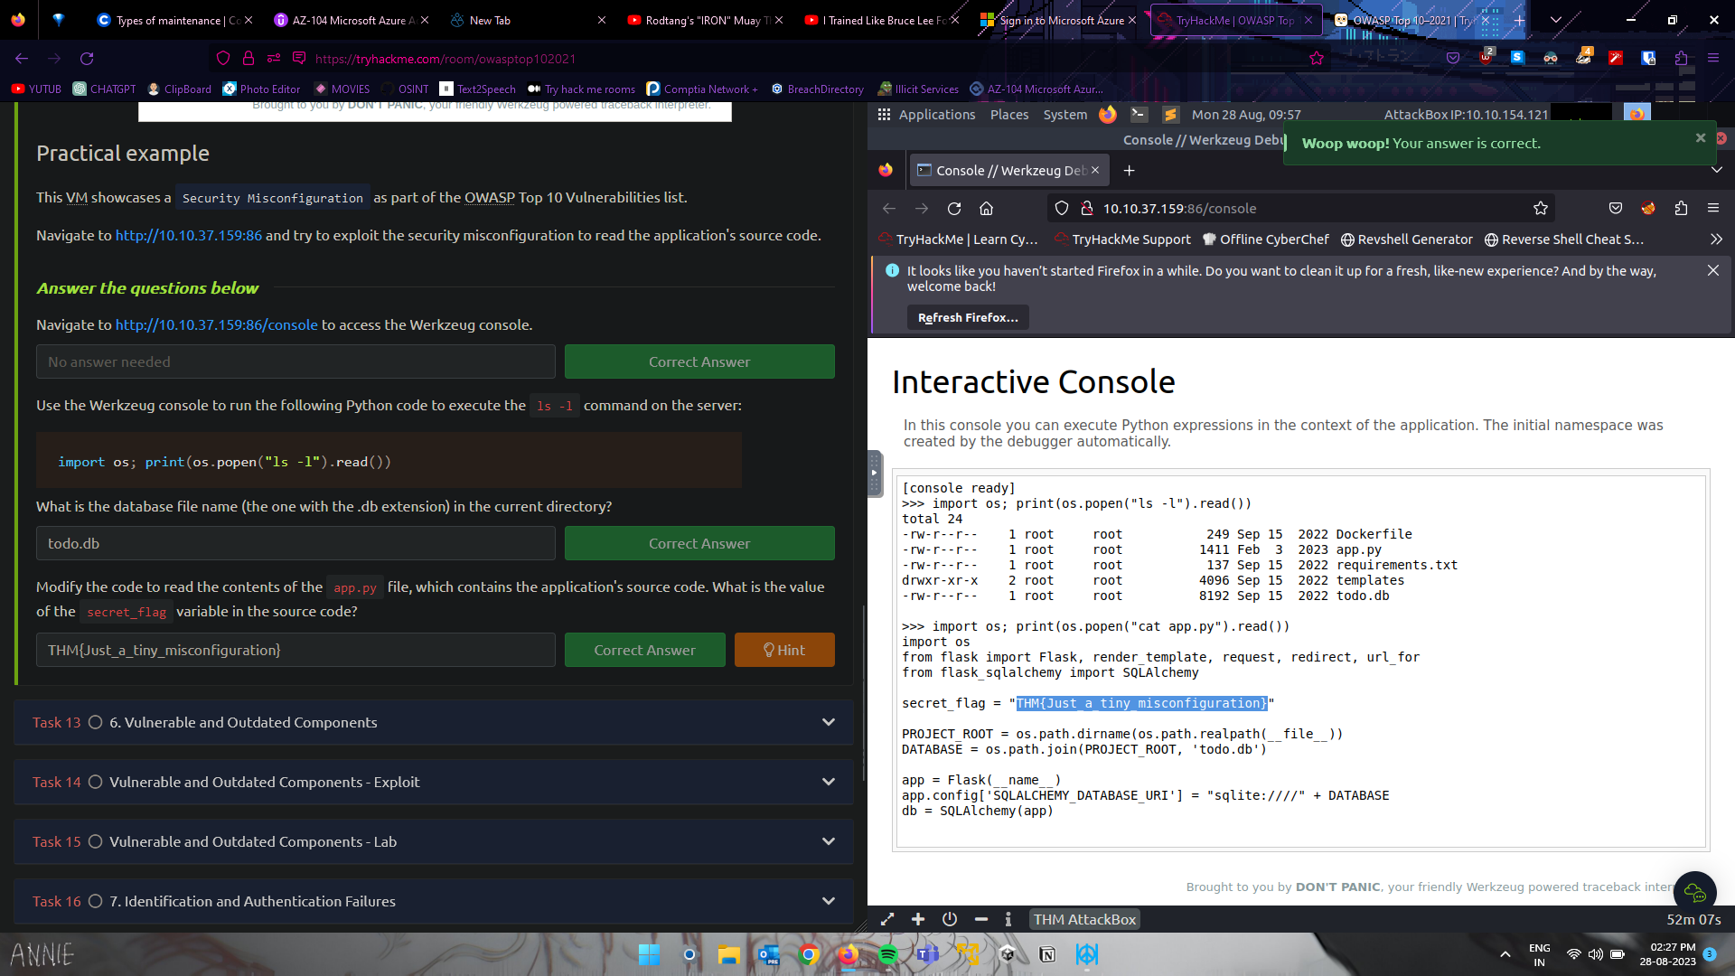

Made use of the console to gain informantion